EE 546C Lab2

Tactile Sensor Design

Date: Apr 10
Location: The Mill

Learning objectives:
- Understand the workflow of the laser cutter and plan the cutting steps accordingly.
- Design the tactile sensors, including the layout, electrode trace patterns, and insulating layer if applicable.
- Use vector graphics software to generate the cutting path for the laser cutter.

Materials:
- Your laptop
- USB drive
- Lab kit (recommended)

Tips：
During the process of using a laser cutter to fabricate sensors, multiple cuts are usually required due to the sensor's multilayer structure and the different materials used in each layer.

This means that it may be necessary to design separate cutting paths for the different layers of the sensor.

Generally, the laser cutter's penetration depth can be controlled by adjusting the laser power and the carriage movement speed, allowing control over how many layers of material the laser cuts through.

The Mill has two laser cutters. When facing the wall, the one on the right is a CO₂ Laser Cutter, and the one on the left is a Fiber + CO₂ Laser Cutter (it has two cutting modes). Either machine can be used to fabricate our sensor, but the CO₂ laser cutter may require multiple power adjustments, which could involve more steps.

If you are using the CO₂ cutting mode, please avoid cutting conductive fabric directly in this mode. This is because the main materials in conductive fabric include nickel and copper, which are highly reflective to CO₂ lasers. The CO₂ cutting mode can penetrate all the materials in the sensor, so it is necessary to adjust the power and speed to control how many layers are cut through.

Using the fiber cutting mode, it can directly cut the conductive fabric and will not penetrate the vinyl transfer tape.

For detailed laser cutter steps, please refer to the Lab 3 instruction.

Tutorial on Designing Cutting Paths for Laser Cutters:

1.Intro
In a laser cutting workflow, the lines and shapes drawn in Inkscape are interpreted as cutting or engraving paths by the laser cutter. It is crucial that all shapes are converted to paths and that stroke colors and widths are properly set to match the laser cutter’s expected input. For example, thin red lines (RGB: 255,0,0, width: 0.01 inch) are often used to indicate vector cutting paths.

2.Software: Inkscape
Inkscape is a vector graphics editor used to create and edit vector images.
Free download link:
https://inkscape.org/

3. Design Steps:
(1) Choose paper size:
Open Inkscape and choose your preferred paper size. A4 landscape is usually a good choice.
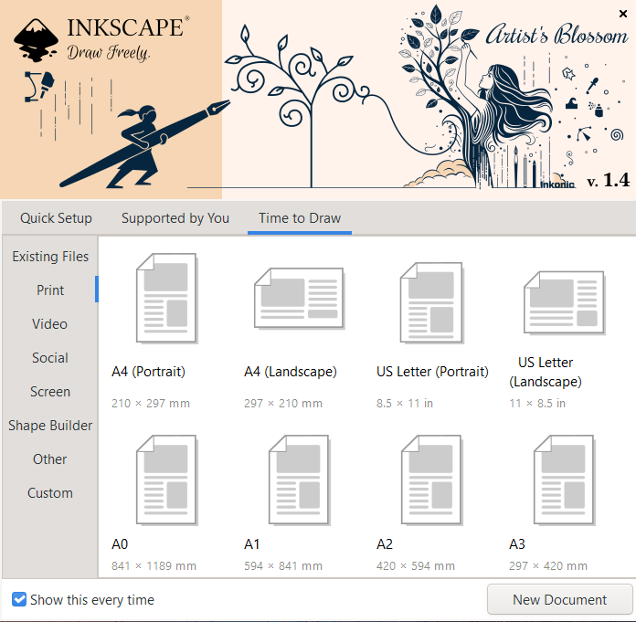

(2) Find drawing tools:
On the far-left toolbar, find the shape drawing tools, such as the rectangle tool or the ellipse tool.Let’s draw a rectangle as an example.
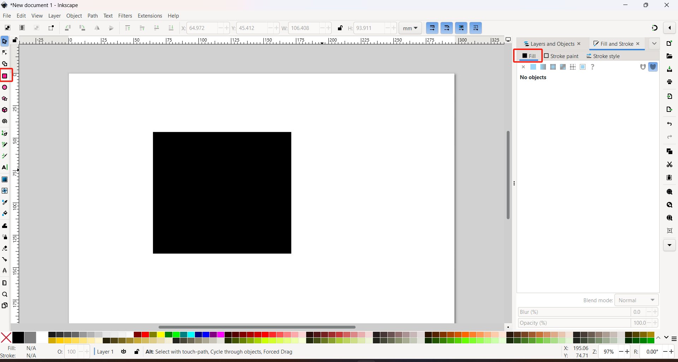

(3) Remove color fill:
The shape you just drew may have a fill color, which is not what we want for laser cutting. The laser cutter reads lines (paths/strokes) to determine the movement path of the laser head. So first, use the topmost Select Tool on the left toolbar to select the rectangle. Then, on the right panel, click on “Fill” and choose “No fill” (the icon with a red X). You should now see only the outline of the rectangle.

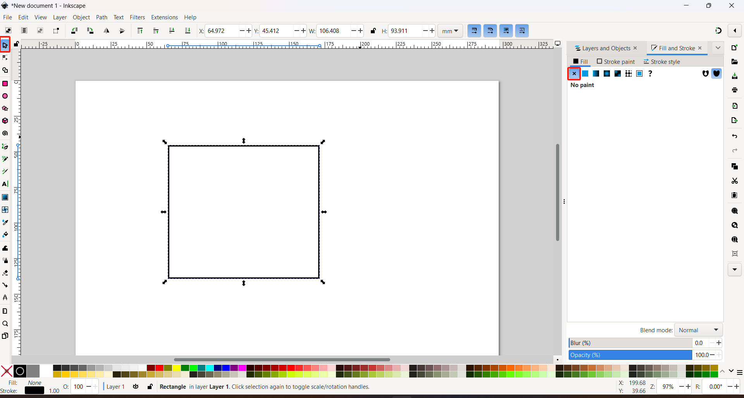

(4) Color recognition of the laser cutter:
Because laser cutting software typically distinguishes operation types by color:
Red usually represents vector cutting;
Blue represents vector engraving;
Black represents raster engraving.

Therefore, we need to set the color of the rectangle outline to red.
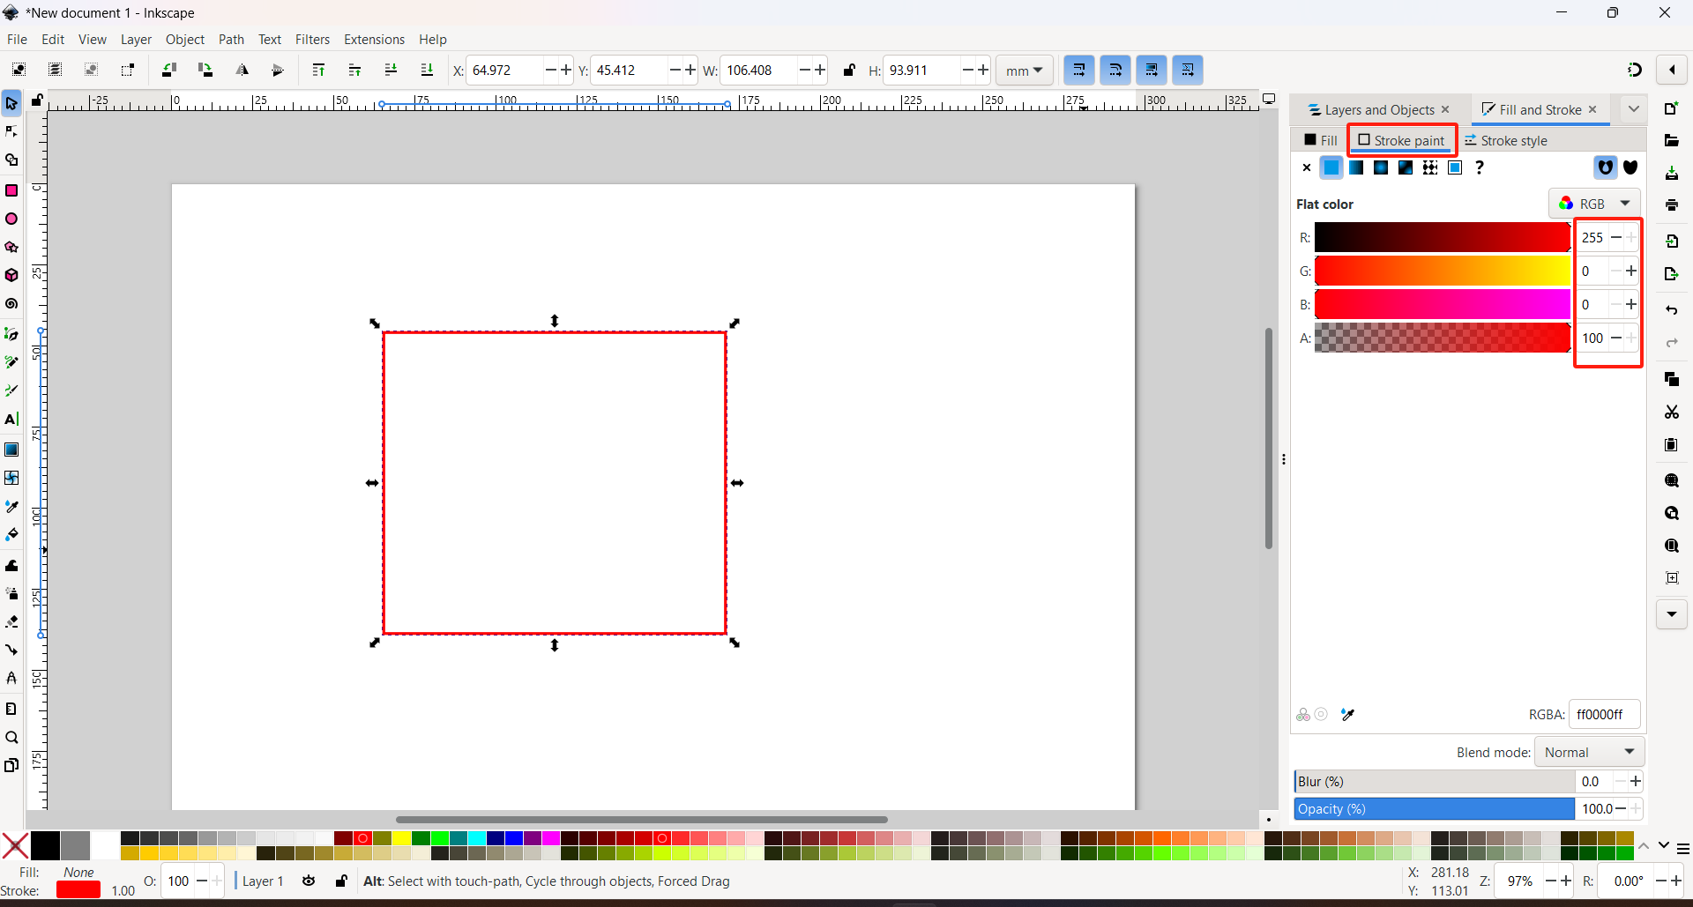

(5) Stroke width:
Many laser cutting systems (such as Universal Laser Systems) only recognize very thin lines (such as 0.001 inch) as vector paths. If the lines are too thick, the software may interpret them as shapes or raster images instead of precise cutting paths.
Therefore, we need to set the stroke width to 0.001 inch (a very thin value).
Make sure to first select the rectangle using the Select Tool before adjusting its color, stroke width, or other properties.
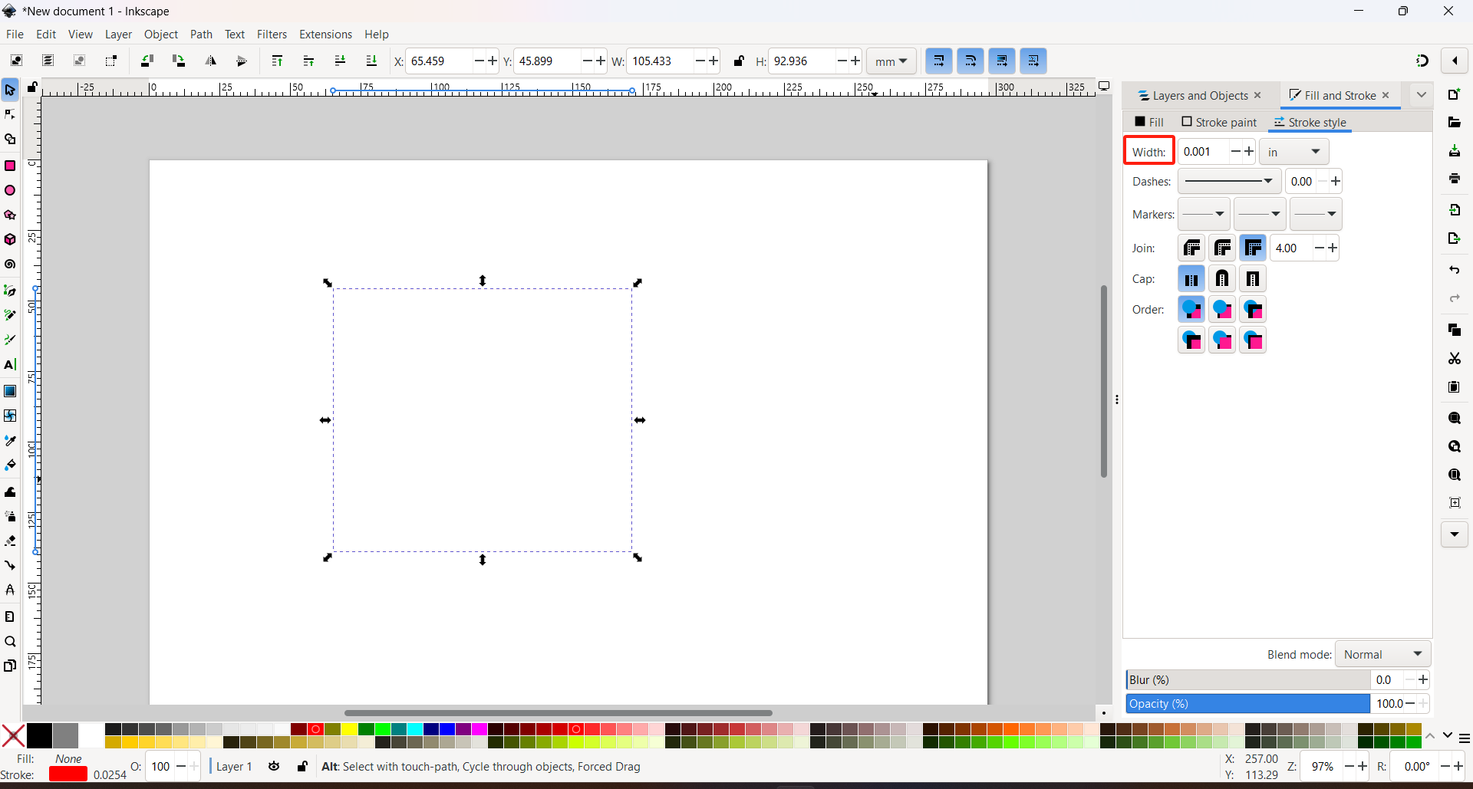

*Tips:
After changing the stroke width, the shape may appear very faint, so you can choose to adjust the stroke width as the last step.
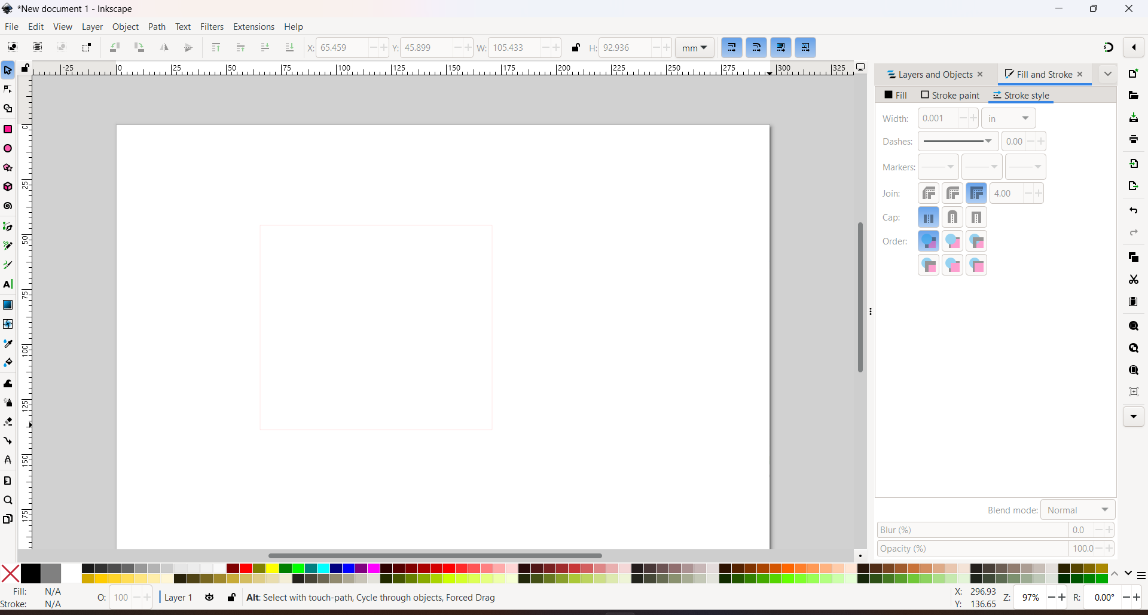

(6) Quickly adjust the size of the graphic:
When your path is selected, you can use the toolbar at the top to set the position coordinates, as well as the width and height of the path.
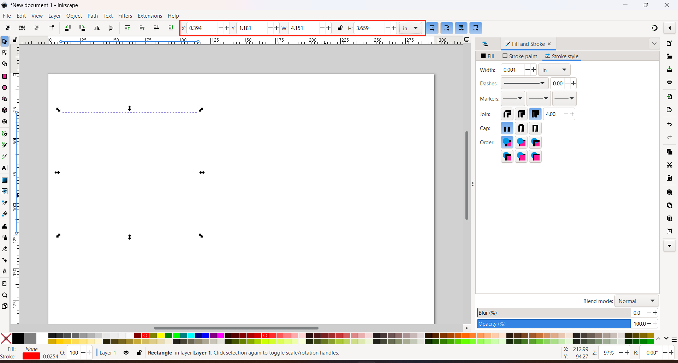

(7) Output the file to USB drive:
Now the cutting path is complete. Then go to "File" → "Save As" and save the file in a format such as .pdf (recommended), .svg, or .dxf. Save the file to your USB drive. After that, we will insert the USB drive into the laser cutter and import the file into the machine.
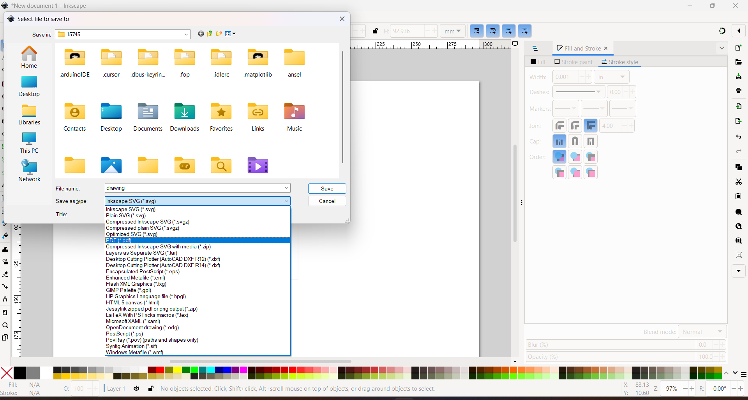

4. Other common drawing operations
(1) Draw arc-like shapes or circles:
If you want to draw arc-like shapes or circles, you can use the Ellipse/Arc Tool from the toolbar on the left. While drawing, you can set the start angle, end angle, and choose whether the shape is closed or open from the toolbar at the top.
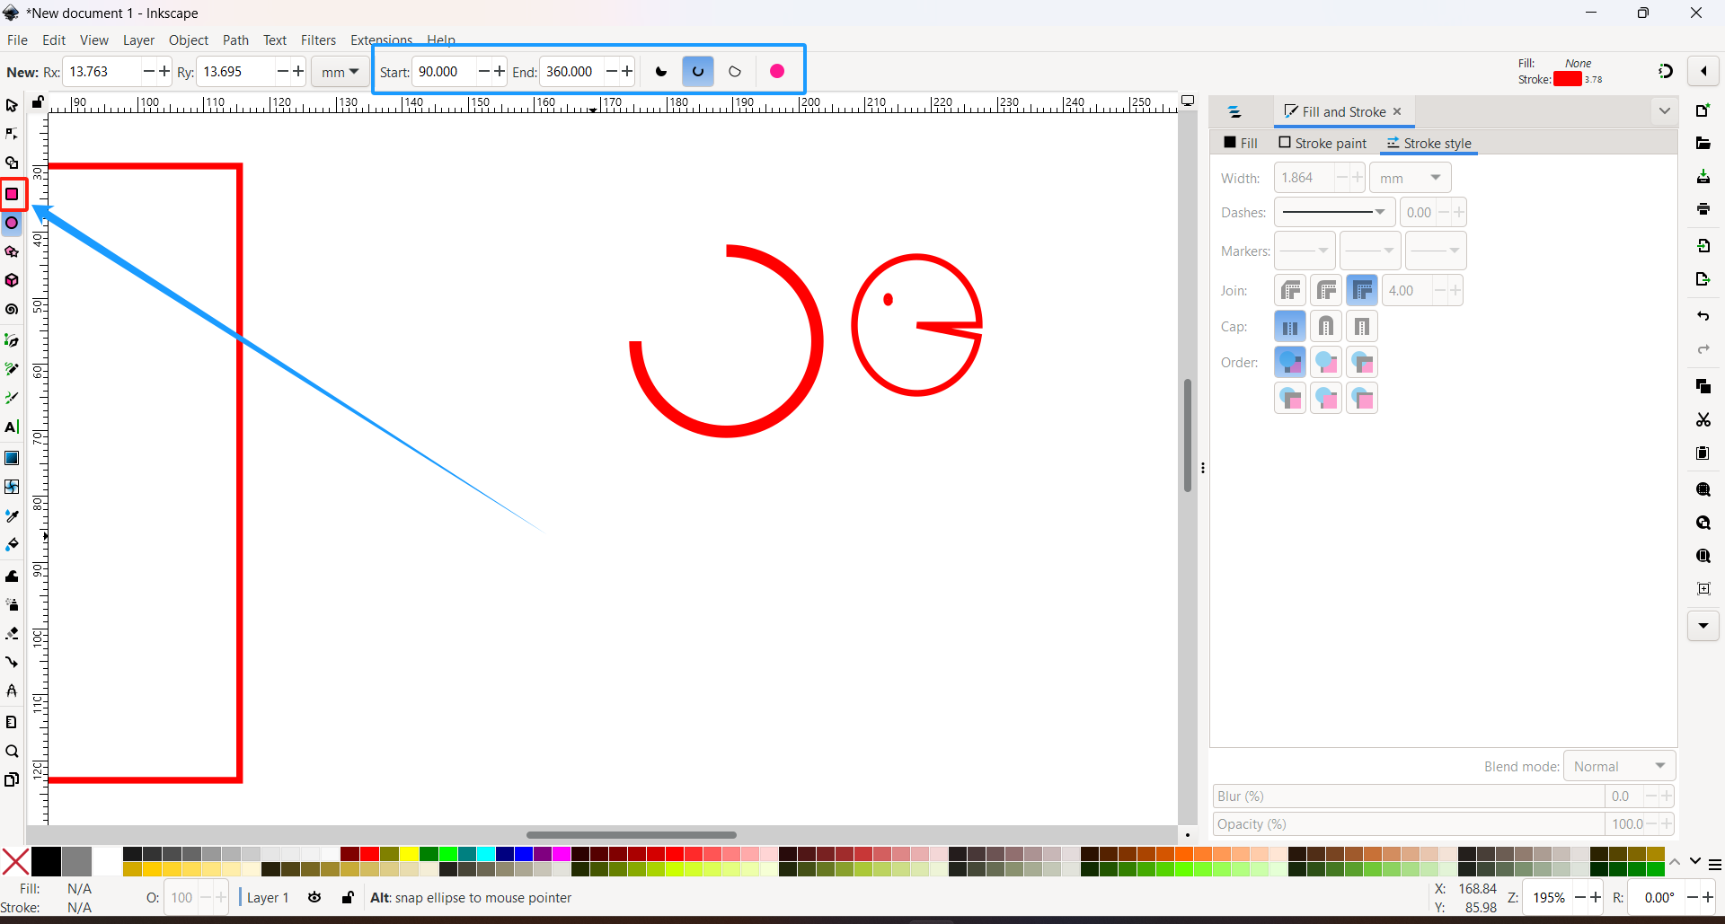

(2) Adjustments could be made later:
Of course, you can also make adjustments later. Simply double-click the shape you want to modify using the Select Tool, and the toolbar at the top will appear for editing.
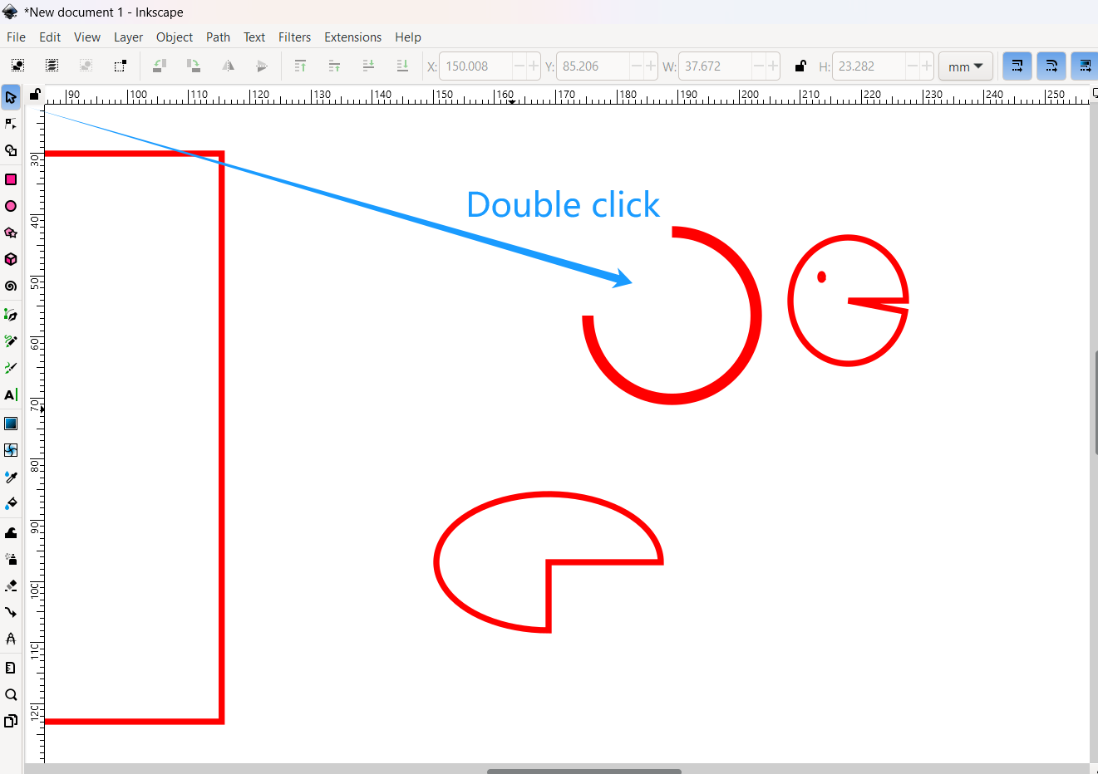

(3） Rotate and flip:
Additionally, if you single-click the shape using the Select Tool, the top toolbar provides options like rotate and flip, which are also very helpful.
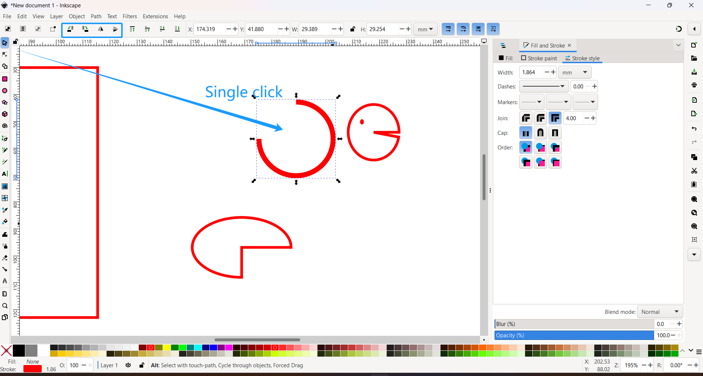

（4） Pen tool：
You can also use the Pen Tool to draw irregular or custom shapes. Left-click to draw lines, right-click to finish the path.
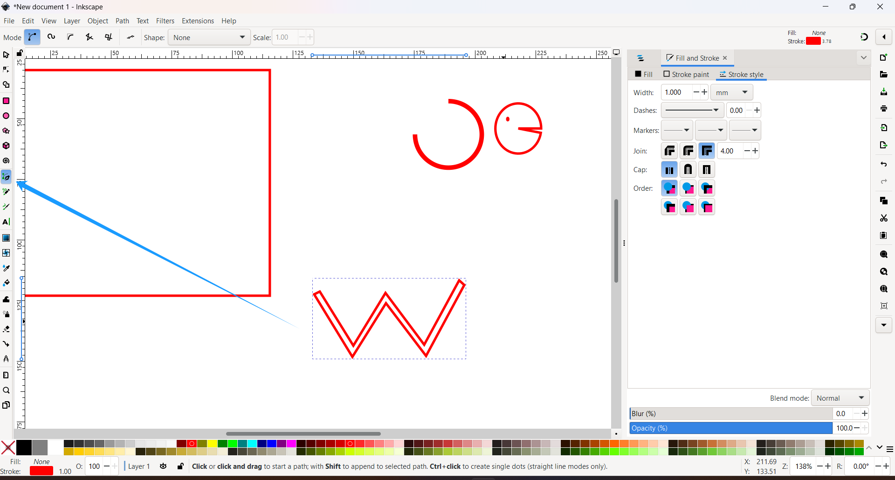

Feel free to explore more features on your own!

